

ICT PROJECT DOCUMENTATION

Group Members:
- Laviza Majeed (03-134252-033)
- Hibah Naeem Rana (03-134252-030)
- Mariah Ahmad (03-134252-035)

Submitted to:
- Ma’am Nadia Shakir

Project Name:
- Shoe Selling Store Website

Report on Website

- Introduction to the website theme
- The Website theme is designed in a way that focuses on pleasant user experience with modern style and appealing look ,highlighting the products (footwear) clearly
- We added home page,about page, FAQs section, and contact page
- We also used flash cards to display products
- Added navigation bar,image slider,drop down menu
- Used icons for contact number, address, and mail
- Added social links to facebook and other social media pages
- Used buttons and add to cart option to shop on products

- Design concept and colour scheme rationale
Colours that are used include mint ,pink and peach that are neutral colours and gives comfort,keeping an easy to look interface that is also appealing to eyes ,to provide positive consumer behaviour and perception of the brand.Also we planned to select different category of colours of light and dark theme
- Figma design process (screenshots)
Figma was used to create a simple layout of the website which was later modified using the layout designs.
- Step-by-step development explanation
We used html to design the basic structure for
1.Home
2.Flash Cards (to include products)
3.Navigation bar, Categories
4.Contact and Gallery
and then applied css for for layout and styling.
Inline Css for headings,and other things.
External Css has been used for every page as well
Javascript has been used at some places for a making it interactive and provide better user
experience
- Responsiveness Strategy
For the website to work properly on different size screens we used flexible layouts and media queries so it works properly on desktop,tablet or mobile screens

- Challenges faced and solution
We made the same class for all the headings and it caused design inconsistency
We applied the functionality for searchbar in javascript
Dark Theme and Light Theme was used but with Dark theme appeared black colour
Responsiveness was managed by testing the website on different screen sizes.

FIGMA SCREENSHOTS:
1)HOME:
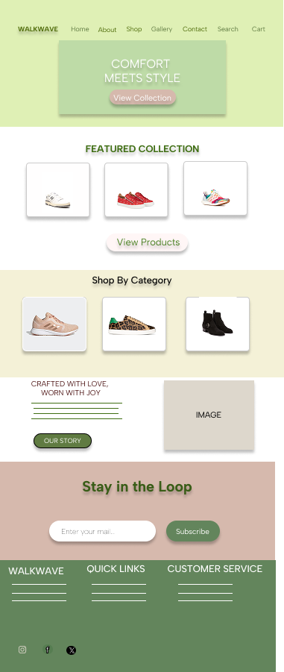

2)CONTACT:
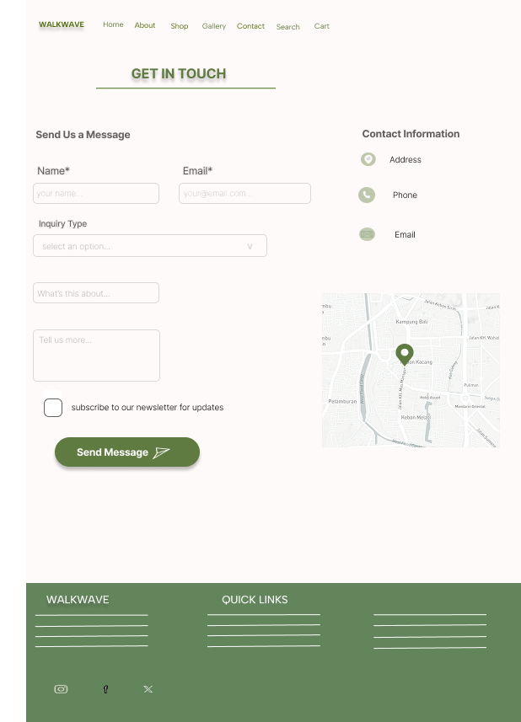

3)SHOP:
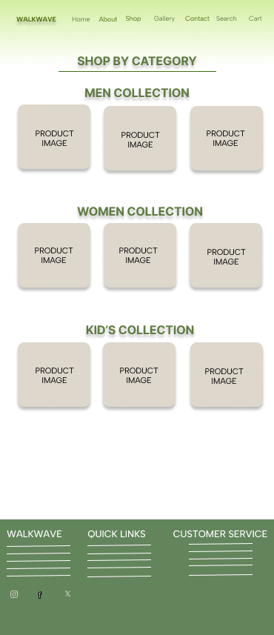

4)GALLERY:
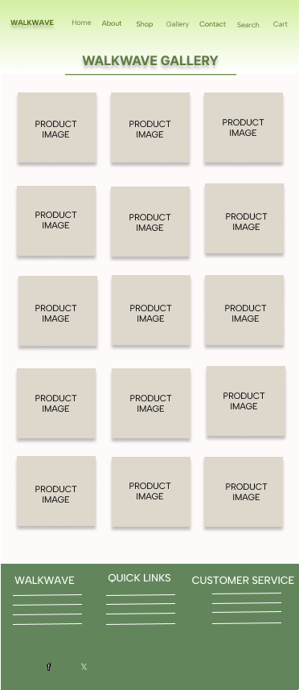
5)ABOUT:
